** Hopedale Community News**

**Volume 33, Number 3 October 2021**

|  |
| --- |
| **Sunday Services via Zoom – Service 10:30 am; Open 10:20 am** |

**October Sunday Services**

**Zoom Invitation Sent by Email from** [***huucoffice@gmail.com***](mailto:huucoffice@gmail.com)

**October 3rd – Reflections on the Second Principle: Justice, Equity and Compassion in Human Relations.** In the words of the Reverend Emily Gage, of Chicago, “Justice, equity, and compassion in human relations points us toward something beyond ‘inherent worth and dignity.’ It points us to the larger community. It gets at collective responsibility. It reminds us that treating people as human beings is not simply something we do one-on-one, but something that has systemic implications and can inform our entire cultural way of being.”  Join Diane Wright and service leader Patty Klingenberg as we consider the ways our day-to-day choices can support our second principle.

**October 10th – Sex and Gender and our Principles.** Sex and gender are not the same thing, and both of them exist on a spectrum. During LGBT History month, on the day before Coming Out Day, service leader Jennifer Blue will lead us in a discussion of sex and gender and sexuality, and how understanding these concepts ties to our principles.

**October 17th – On Growing Older:  It's Better Than the Alternative**. Taking ideas from personal experience, books, and the comics, service leader Linda Amspaugh will explore the process of growing older.  What do you have to look forward to?  How do "old people" cope?  Are there advantages in being the oldest one in the room?  Are there connections between growing older and our Principles and Traditions?  Let's have conversations about this stage in life.

**October 24th – The Cooperative Model**. Please join Carla Blackmar, board member of the MOON cooperative; to discuss the ways producer, consumer, and worker cooperatives can help build thriving communities. She will present three types of cooperative economic structures, and provide local examples of how cooperatives prioritize people over profit. Service leader: Patty Klingenberg

**October 31st –** (Hallowe’en!) **“What Am I Scared Of?”** After service leader Doris Bergen briefly discusses the role being scared may play in our positive (or negative) responses to life, participants will be invited to briefly share personal scary thoughts and how they cope with them to make their lives more resilient and productive. The purpose of this service is to help us be more confident and proactive in making our lives a little more comfortable, and our actions more effective as we meet today’s especially scary challenges.

****

**Notes From Board President Curt Ellison**

***ellisocw@miamioh.edu***

**Thanks**

Our Zoom Sunday services for the new church year have revealed a lot of good thought, energy, imagination and music, and attendance appears to be increasing. Children’s religious education continues via Zoom during the pandemic as health risk precludes large outdoor gatherings. Small RE outdoor events, however, are being planned. Gardeners and groundkeepers have the grounds and flowerbeds looking sharp, and the fine vegetable garden productive. There is a newly renovated stairway between play areas that both functions well and looks great. We have distributed new guidelines for face-to-face activities developed by the In-Person Gatherings Task Force and approved by the Board. Donors have been generous to the Hopedale Facilities Fund, and the Construction Task Force is actively focusing facilities improvement plans. All the fine people keeping our community whole and the Hopedale spirit rich in these ways are greatly appreciated!

**Gathering In Person**

After considering public health information, the results of a congregational survey, UUA guidelines, and approaches taken by other UU congregations, the In-person Gatherings Task Force wrote guidelines and designed a rubric for evaluating the health risks of our community’s face-to-face interactions. These are keyed to scientific information, and the Board reviewed and approved them, along with a decision-making process. You can find details at the end of this *Newsletter*. Hopedale guidelines are keyed to epidemiological trends for Butler County as reported daily by health care professionals, and will guide decisions about gathering in person when safe to do so. If you have questions, contact Neil Danielson, Task Force Lead, at [*danielnd@miamioh.edu*](mailto:danielnd@miamioh.edu) or 513-523-3202.

**A Multiplatform Future**

The In-Person Gatherings Task Force is aware that Zoom gatherings have been beneficial to those who cannot physically attend our services, to those who are located far from our Hopedale home, or to invited guests and speakers in distant locales. The Task Force is exploring the prospect of providing Zoom links to future in-person services and events, and evaluating equipment to make that happen as seamlessly as possible. We received support from the Monroe Husbands Grant Committee of the Midwest Unitarian Universalist Conference for this initiative, and commitments from Hopedale donors.

**Facilities Planning**

Facilities improvement priorities indicated by the Congregation in March include finishing the lower level for RE; installing an elevator or lift for multi-level access; upgrading restrooms; rehabilitating driveway and parking areas; and adding hard-surface parking. Donors to the facilities fund have been generous and mortgage rates remain favorable, yet during the pandemic construction costs have risen. The Task Force is pursuing cost estimates and planning for an update about facilities planning at the fall Congregational Meeting anticipated for late November. If you have questions now, contact Curt Ellison at [*ellisocw@miamioh.edu*](mailto:ellisocw@miamioh.edu) or 513-461-1131.

**Board Meetings**

Upcoming Board meeting dates for fall 2021 are October 12, November 9 and December 15. Anyone may attend via Zoom. Contact Curt Ellison for the invitation.

*The organizational meeting for what would become the Hopedale Unitarian Universalist Community took place September 17, 1989 in Oxford. A brief announcement in the* Oxford Press *drew more than thirty people to confer with one another and a UUA consultant, and the rest is, as some might say, history. “If you are unsure of an ongoing interest,” the announcement read, “but would like to meet some local religious liberals, please plan on attending. Refreshments and goodwill provided.” Well met!*

**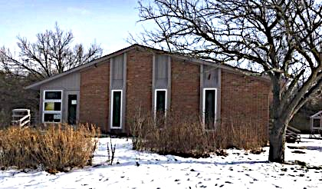**

**Stewardship**

**By Drew Ruther, VP**

**513-265-1538 andrew.ruther@gmail.com**

Greetings Hopedale Members & Friends,

The more time I spend working on the Hopedale grounds, the more I appreciate the outdoor spaces that we have. The vegetable gardens are always lovely and bountiful. The front beds are a collage of colors throughout the season. We’ve got a basketball court, playset, and open fields for the children. There’s even hiking trails for the woodsy folks, and a few picnic tables for the socializers. It truly is a lovely setting.

For those keeping tabs, our upper-level air conditioner was replaced and is now fully operational. Many thanks to Pete and Kathleen Carels. The inner-workings of the building seem to be in good shape. The heating system will get a tune-up before the winter cold arrives and our cleaning lady is still making visits. If anyone wishes to do any tidying or cleaning inside the building, please let me know.

We will hold two outdoor work sessions in October on Saturday, Oct. 2nd and Saturday, Oct. 30th, both from 9:00 AM until 11:00 AM.

As always, contact Drew Ruther at [andrew.ruther@gmail.com](mailto:andrew.ruther@gmail.com) or 513-265-1558) with questions.

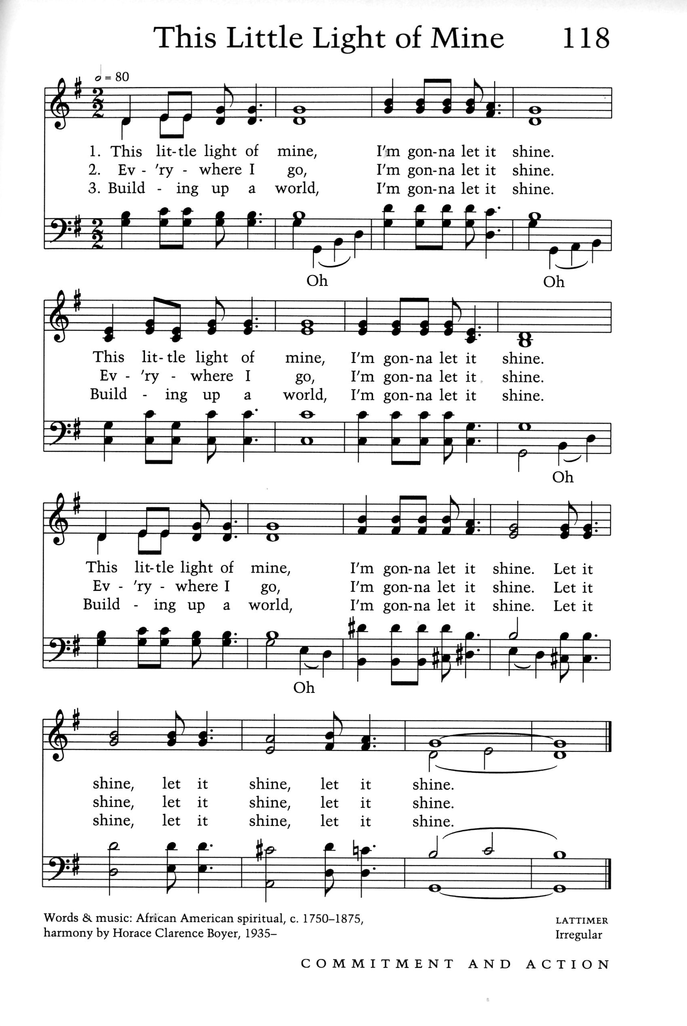

**Religious Education CONNECTION**

**Genevieve O’Malley Knight, RE Coordinator 513-593-3275**

***Genevieveaok (at) yahoo (dot) com***

**RE Committee: Jennifer Blue, Valerie Elliott, Adriane Ruther; Darrel Davis (VP, Religious Services)**

***Children’s RE & Activities – “one-room schoolhouse”***

**Sunday, October 3rd** – Cartuuns class led by Adriane Ruther (Zoom); 9:30 a.m.

**Sunday, October 17th** – no class – Talawanda three-day weekend

*The next Zoom cooking RE event will be a “Sunday Morning of Sundaes.”*

**Saturday, October 9th** – **PUMPKIN DECORATING**

These face-to-face events are both weather and COVID-dependent – stay tuned for emails/texts with updates about these tentative plans:

Middle School kids (5th-8th grade) – time tbd

Elementary School kids (K-4th grade) – time tbd

We will provide small pumpkins to paint, and tools for other pumpkins that kids bring to carve. RSVPs are required to keep group sizes small – contact Genevieve, 513-593-3275.

If these small-group events for younger kids are successful and weather & COVID cooperate, RE plans to sponsor pumpkin-decorating events for the rest of you too!

And if you can’t wait to get in on the fun, volunteers are needed to help the first groups.

**Saturday, October 30th** – **TRUNK-OR-TREAT**

Hopedalians are invited to drive their vehicles to Hopedale’s parking lot with goodies in the trunk for sharing with Hopedale kids. Please arrive and be set up by 5:45 p.m. There will be no vehicle traffic between 5:50 and 6:30 because the kids will be visiting your trunk starting at 6:00 p.m. Be sure your set-up allows kids to safely pick up their own treat. Masking required. Adults consider wearing a costume and/or decorating your car/trunk.

***Adult RE***

More book discussions via Zoom will be coming soon. Please contact Genevieve if you have read something you’d like to share.

**Notes from the Social Justice Committee**

**By Liz Woedl**

**Social Justice Committee: Liz Woedl, Libby Earle, Mary Fox, Peggy Branstrator, Bethany Smith,**

**Russ VieBrooks**

**Immediate Witness**

Be on the lookout for announcements about discussions surrounding the Actions for Immediate Witness from General Assembly (texts sent in advance of our 8/22 service).

**UUJO**

For information about Unitarian Universalist Justice Ohio, please visit their website, *UUJO.org*. UUJO serves the 38 UU congregations and fellowships across Ohio with a mission to offer education, advocacy and action consistent with Unitarian Universalist liberal religious principles and to witness with and on behalf of marginalized groups and individuals.

***“There is no such thing as a single-issue struggle because we do not live single-issue lives.”***

*– Audre Lorde*

**Environmental Corner**

**By Peggy Branstrator**

***jonwb@earthlink.net***

It’s easy to get discouraged about the urgent environmental threats facing us every day! The IPCC Climate Report is truly scary, hurricanes form in the Atlantic one after another, the oldest Sequoia trees in the nation are threatened by fire, and the Ohio General Assembly is back in session considering many bills environmentalists do not support. It can seem overwhelming!

But in the midst of this there are some bright spots we can focus on. Averting the worst consequences of Climate Change does not depend on any ONE solution; it depends on multiple solutions. We need to do lots of things, which means there are different opportunities for each of us to do SOMETHING. The “something” you can do will depend on your skills and opportunities. Think about what you can do well and then DO IT. Regularly!

The number of Hopedale households with solar on the roof is now FOUR! The Ruthers also have a solar roof! They used a different supplier than others and had to navigate Butler Rural, instead of Duke, so they are another information resource for anyone considering solar.

The Oxford Seniors Ecoclub is finishing up the postcards to the Public Utility Commissioners and will start writing to Legislators to urge the termination of the OVEC coal plant subsidies. Join them at 2:30 on Wednesday, October 13, or contact Peggy to write some on your own.

Do you compost? You can put food waste (and pizza boxes) in the city cans at the end of Main Street, bring to the Hopedale compost bin or start your own! Make soil, not methane! Not your thing? OK, pick something else! And talk to others about what you are doing! The Yale Global Warming Conversations poll shows that 62% of Ohioans are concerned about climate change, including a majority in EACH county! There is more support than you may realize!

Several groups are making plans to challenge the new, still-highly-gerrymandered legislative districts. Can you write a letter, email or make a phone call? It took many people to get the legislation passed; it will take many to get it implemented!

Fall is the perfect time to plant trees, backyard wildlife habitat or pollinator gardens! Every tree removes carbon dioxide! Someone has actually attempted to estimate how many trees would need to be planted to offset current carbon emissions! Global organizations are mounting massive tree-planting campaigns! Oak trees support hundreds of species of caterpillars that birds feed their babies in the spring! We have planted oak trees in several places at Hopedale recently and have a few small oak trees left over. Do you want one? Peggy also has extra baby butterfly bushes!

The legislation to allow radium-containing waste drilling fluids to be sold as “commodities” for ice control is back before the Ohio legislature again. UU Ohio Justice

has been active in educating UU Congregations about these bills – HB272 and SB171. The waste brine, called AquaSalina, has been used on Ohio roads by ODOT previously, but this practice has been discontinued recently due to citizen protest! However, local communities and individuals can still use it. If radium gets on roads, it will also get into roadside soil, get carried home on tires and otherwise spread everywhere! Since there is no “SAFE” exposure amount for radium (and the radon gas it releases) these fluids have been regulated in the past as “Hazardous Waste”. More information is available from the Ohio Brine Task Force.

Don’t get discouraged! Little things do add up! DO SOMETHING TODAY and you will feel better!!

**Congregational Life**

**By Celia Ellison, VP**

**513-461-1204,** [***knightcm@miamioh.edu***](mailto:knightcm@miamioh.edu)

**It’s the kindness** from all of you reaching out to one another in small or big ways that is so important: a card, a call, a visit, a meal, whatever it might be. You are this community.

**HOPEDALE EXPLORES**

If there is a topic you might like to present or hear about or participate in for a future Hopedale Explores, please let me know!

**UU PRINCIPLES from a HOPEDALE PERSPECTIVE**

The Sunday Service Committee is planning a Sunday service focused on each principle for this program year. Doris Bergen presented the First Principle in September and Diane Wright will present the Second Principle on October 3rd. The speakers’ written presentations will be shared with me so we have a collection of all of them for posterity and maybe a future New to UU class.

**TRUNK-OR-TREAT**

See announcement in RE Connections or Happenings at Hopedale!

|  |
| --- |
| **Around Hopedale**  **By Celia Ellison, VP, Congregational Life** |

**REMEMBERING WAYNE COPENHAVER**

Last month’s *Newsletter* contained a note from Orlita Kissane expressing her appreciation to the Hopedale community for support during Wayne’s illness, and a notice about his memorial service, which will be both in person and available via Zoom.

On **Saturday, October 2nd, at 1:30** we are holding a Quaker-style memorial service/ Celebration of Wayne’s life at First Friends Meeting, located at 2010 Chester Boulevard in Richmond, Indiana, where Wayne spent the last 20+ years of his working life. For those attending in person, **masks will be required**, and social distancing will be observed.

Zoom Link: us02web.zoom.us/j/4379169788

Meeting ID: 437 916 9788

Password: 7RCQ0F

|  |
| --- |
| **Staying Connected** |

***Eunice is celebrating her Carol Hennessey has moved to Florida:***

***90th birthday in October:*** Carol Hennessey

Eunice Meadows Cypress Creek Assisted Living #D 48

468 Hermay 970 Cypress Village Blvd.

Hamilton, OH 48013 Sun City, FL 33573

|  |
| --- |
| **References from September Services** |

**September 5 “**Our First Principle” with **Doris Bergen**

Story for All Ages:*Tomorrow I’ll Be Kind* written and illustrated by Jessica Hische

[*https://www.uua.org/beliefs/what-we-believe/principles/1st*](https://www.uua.org/beliefs/what-we-believe/principles/1st)

[*https://jeffersonunitarian.org/new-here/beliefs-values/uu-principles-and-sources/*](https://jeffersonunitarian.org/new-here/beliefs-values/uu-principles-and-sources/)

[*https://firstparishnorwell.org/sermons/inherentworth.html*](https://firstparishnorwell.org/sermons/inherentworth.html)

**September 12 “**Shock and Fright and Quiet Candlelight: 20 Years Later”

Remembering the day after 9/11 with **Diane Wright**

Story for All Ages: *Fireboat: The Heroic Adventures of the John J. Harvey* by Maira Kalman

[*http://theweek.com/captured/647651/september-12-2001*](http://theweek.com/captured/647651/september-12-2001)

*[https://www.youtube.com/watch?v=hDPFukcWFsA](https://www.youtube.com/watch?v=hDPFukcWFsA" \t "_blank)*   (Sandler O’Neill)

*[https://www.youtube.com/watch?v=AOQg4u9bFTs](https://www.youtube.com/watch?v=AOQg4u9bFTs" \t "_blank)* (People - Children of 9/11)

*[https://www.youtube.com/watch?v=18lsxFcDrjo&t=530s](https://www.youtube.com/watch?v=18lsxFcDrjo&t=530s" \t "_blank)* Boatlift

*[https://www.youtube.com/watch?v=MqWZfLA1Sgs](https://www.youtube.com/watch?v=MqWZfLA1Sgs" \t "_blank)* Come from Away

*[https://www.youtube.com/watch?v=WKlqof\_Vvbg](https://www.youtube.com/watch?v=WKlqof_Vvbg" \t "_blank)* Trumpet, World Series

*Atlantic* article about Bobby McIlvaine: *[https://www.theatlantic.com/magazine/archive/2021/09/twenty-years-gone-911-bobby-mcilvaine/619490/?utm\_source=Mash-Up+Americans+Newsletter&utm\_campaign=e33f39ba1f-Weekly\_Newsletter\_010618\_COPY\_01&utm\_medium=email&utm\_term=0\_b7389b4eea-e33f39ba1f-296850361](https://www.theatlantic.com/magazine/archive/2021/09/twenty-years-gone-911-bobby-mcilvaine/619490/?utm_source=Mash-Up+Americans+Newsletter&utm_campaign=e33f39ba1f-Weekly_Newsletter_010618_COPY_01&utm_medium=email&utm_term=0_b7389b4eea-e33f39ba1f-296850361" \t "_blank)*

**September 19 “**The Jewish New Year: Myth and Reality” with **Terry Perlin**

Story for All Ages: *Forgive and Let Go! A Book about Forgiveness* by Cheri J. Meiners

Illustrated by Elizabeth Allen.

Recommended Reading:

*Essential Judaism: Updated Edition: A Complete Guide to Beliefs, Customs & Rituals*

by George Robinson

*The Jewish Way: Living the Holidays* by Irving Greenberg

*The Israeli-Palestinian Conflict: What Everyone Needs to Know* by Dov Waxman

**September 26** “What We’ve Learned During the Pandemic” with **Cynthia Kelley and Genevieve O’Malley Knight**

A discussion about the different types of things learned during the past year and a half.

Story for All Ages: *Wade through the Pandemic* by Wade and Joshua Williams

Selected readings from *Shelter in this Place: Meditations on 2020* Meg Riley, Ed., Skinner House Books.

|  |
| --- |
| **Happenings at Hopedale** |

**Saturday, October 2nd** – Celebration of **Wayne Copenhaver** -- 1:30 pm, First Friends Meeting in Richmond, Indiana. See “Around Hopedale” for details and Zoom link.

**October 2nd** – Outdoor work session from 9:00-11:00 am.

**October 6th** – Wednesday Wine (or something else) 5 pm or so at Cru in Oxford.

**October 12th** – Hopedale Board meets via Zoom. If you wish to join this meeting, email [ellisocw@miamioh.edu](mailto:ellisocw@miamioh.edu) or call 513-461-1131 for the Zoom invitation.

**October 30th** – Outdoor work session from 9:00-11:00 am.

**Saturday, October 30th** – **TRUNK-OR-TREAT**

Hopedalians are invited to drive their vehicles to Hopedale’s parking lot with goodies in the trunk for sharing with Hopedale kids. Please arrive and be set up by 5:45 p.m. There will be no vehicle traffic between 5:50 and 6:30 because the kids will be visiting your trunk starting at 6:00 p.m. Be sure your set-up allows kids to safely pick up their own treat. Masking required. Adults consider wearing a costume and/or decorating your car/trunk.

|  |
| --- |
| **Support for Hopedale** |

*Pledge* payments or donations can be made to “Hopedale UU Community” by mail to our Treasurers, Richard and Judy Schlub, 2849 Stone Mill Way, Hamilton, OH 45011.

Donations the *Hopedale Facilities Fund*, devoted entirely to physical improvements for our Hopedale home, may be mailed to the Treasurers along with the donor commitment form. Hopedale Community members are being generous, and are greatly appreciated. We cannot, however, meet the congregation’s stated aspirations for facilities improvements without donor support. If you are considering a commitment and need the donor form, or have questions about the progress of our planning or how the Facilities Fund works, contact the Treasurers or Board President Curt Ellison at [ellisocw@miamioh.edu](mailto:ellisocw@miamioh.edu) or 513-461-1131.

|  |
| --- |
| **Beyond Hopedale** |

** Fall 2021 Chalice Lighters**

Chalice Lighter grants are funded by small donations from individuals that are pooled together to help congregations across the UUA MidAmerica Region. A grant of over $10,000 is awarded to one congregation after each annual Call for a project identified by that congregation, and grants of up to $1000 are available via Faithify campaigns.

The Chalice Lighter program is an excellent example of mutual aid among our region’s congregations. To be eligible for a grant, a congregation is expected to support the program through voluntary donations by its individual members. Hopedale has benefited from several Chalice Lighter grants, including one for our outdoor playground, and another of $9,000 in support of our building’s lower level upgrades to religious education space.

The Fall 2021 Chalice Lighter Call supports the plan of the Unitarian Universalist Church of Columbia Missouri to make their space accessible to individuals with disabilities in order to be compliant with the Americans with Disabilities Act and to align with their mission to be radically welcoming to all. They propose installing automatic doors at their main and rear entrances as part of a larger project to add an elevator and make other accessibility improvements.

The fall 2021 *Faithify* campaign supports the Second Unitarian Church of Omaha, Nebraska, which seeks to increase the hours of their Director of Religious Education in order to live up to their religious education goals.

If you would like to help Hopedale play our part in mutual support of MidAmerica UUA congregations by donating to the Fall 2020 Chalice Lighters, you can choose a donor option at <https://www.uua.org/midamerica/giving/chalice-lighters>, or send a check with the notation “Chalice Lighters Fall 2021 Call” or “Annual Donation” in the memo line to MidAmerica Region UUA, 2355 Fairview Avenue N #312, Roseville, MN 55113. Celia Ellison can respond to questions about how this project benefits both Hopedale and the UUA, 513-461-1204.



|  |  |  |
| --- | --- | --- |
|  |  |  |



